File permissions in Linux

Project description
View and change access permissions in linux.

Check file and directory details
Ls -la shows permissions, lists hidden files and shows directories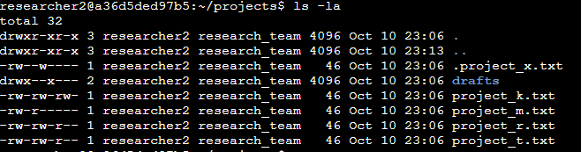

Describe the permissions string
– - - - - - - - - -
Type
User
Group
Other
r - read w - write x - execute

Change file permissions
“chmod o-w project_k.txt” removes writing permissions from others

Change file permissions on a hidden file
“chmod rw-go .project_x.txt chmod g+r .project_x.txt” removes read and write permissions from group and others for project_x.txt, replaces read permissions for group.

Change directory permissions
“chmod g-x drafts” removes execute permissions from the group for the drafts directory

Summary
This project showed the use of ls commands to list files in a directory, and used chmod to change the permissions of users, groups, and others.

